Sprint Plan for Mission 3: Turners Car Insurance Project

### **Team Members**

* **Project Coordinator and QA Specialist:** [Your Name]
* **Frontend Developer and UX/UI Designer:** John
* **Backend Developer and API Specialist:** Tajul

### **Sprint Goal**

Complete initial frontend and backend setup, integrate AI API, and start developing key functionalities.

### **Sprint Duration**

**Week 1:** Planning and Initial Development. **Week 2:** Development and Testing. **Week 3:** Final Development, Presentation, and Submission.

### **Week 1: Planning and Initial Development**

#### **Project Coordinator**

* **Organize the Kickoff Meeting**
  + Schedule the meeting
  + Prepare meeting agenda
  + Conduct the meeting
  + Document meeting notes and action items
* **Set Up JIRA Board**
  + Create the project in JIRA
  + Define and create tasks and subtasks
  + Assign tasks to team members
  + Set deadlines and priorities
* **Start Creating Test Plans**
  + Outline testing strategy
  + Identify key areas to test
  + Develop initial test cases

#### 

#### 

#### 

#### 

#### 

#### **Frontend Developer and UX/UI Designer (John)**

* **Create Wireframes and Prototypes**
  + Draft initial wireframes using Figma (Due: Mid Week 1)
  + Review and iterate on wireframes based on feedback (Due: End of Week 1)
  + Finalize prototypes
* **Set Up Frontend Framework**
  + Choose frontend technologies (Due: Mid Week 1)
  + Set up project structure (Due: End of Week 1)
  + Implement basic layout and components

#### **Backend Developer and API Specialist (Tajul)**

* **Set Up Backend Environment**
  + Choose backend technologies (Due: Mid Week 1)
  + Set up project structure (Due: End of Week 1)
  + Implement basic API endpoints
* **Integrate Generative AI API**
  + Research API documentation (Due: Mid Week 1)
  + Implement API integration (Due: End of Week 1)
  + Test API functionality

#### 

#### 

#### 

#### **Mob Programming Sessions**

* **Initial Setup (Monday-Wednesday)**
  + Schedule: Daily 1-hour session
  + Focus: Setting up project structure, choosing technologies, and initial implementation.
  + **Driver Rotation:** Rotate driver role every 30 minutes.
* **Wireframes and Backend Setup (Thursday-Friday)**
  + Schedule: Daily 1-hour session
  + Focus: Finalizing wireframes and setting up backend environment.
  + **Driver Rotation:** Rotate driver role every 30 minutes.

### **Week 2: Development and Testing**

#### **Project Coordinator and QA Specialist (You)**

* **Facilitate Daily Standups**
  + Schedule and run daily standup meetings
  + Track progress and address blockers
* **Develop and Execute Test Plans**
  + Create detailed test cases
  + Perform unit testing
  + Conduct integration testing
  + Document and fix bugs

#### **Frontend Developer and UX/UI Designer (John)**

* **Continue Frontend Development**
  + Implement UI components (Due: Early Week 2)
  + Ensure responsiveness and interactivity (Due: Mid Week 2)
  + Conduct usability testing (Due: End of Week 2)

#### **Backend Developer and API Specialist (Tajul)**

* **Continue Backend Development**
  + Develop additional API endpoints (Due: Early Week 2)
  + Implement database management (Due: Mid Week 2)
  + Ensure secure data handling (Due: End of Week 2)

#### **Mob Programming Sessions**

* **Frontend and Backend Development (Monday-Wednesday)**
  + Schedule: Daily 1-hour session
  + Focus: Developing key functionalities, integrating frontend and backend.
  + **Driver Rotation:** Rotate driver role every 30 minutes.
* **AI Integration (Thursday-Friday)**
  + Schedule: Daily 1-hour session
  + Focus: Implementing and testing the AI integration.
  + **Driver Rotation:** Rotate driver role every 30 minutes.
  + **Roles:** Each member will get a chance to work on the AI integration, ensuring everyone gains experience with this key feature.

### **Week 2: Development and Testing**

#### **Project Coordinator and QA Specialist**

* Continue coordinating the team’s progress.
* Oversee the implementation of tests and ensure all API endpoints are covered.

#### **Frontend Developer and UX/UI Designer**

* Implement the UI elements and integrate them with the backend.
* Coordinate with the backend developer to ensure proper API integration.

#### **Backend Developer and API Specialist**

* Develop remaining API endpoints.
* Ensure all endpoints are functioning correctly and efficiently.

#### **Mob Programming Sessions**

* Conduct regular mob programming sessions to collaboratively tackle challenging tasks and ensure code quality.

#### 

#### 

#### **Testing Strategy**

Our testing strategy ensures that the backend API endpoints are robust, reliable, and meet the required specifications. We are utilizing Jest as our testing framework, Supertest for HTTP assertions, and mongodb-memory-server to run an in-memory instance of MongoDB for isolated and fast tests.

**Testing Tools and Libraries**

* **Jest:** A comprehensive JavaScript testing framework.
* **Supertest:** A library for testing HTTP APIs.
* **mongodb-memory-server:** An in-memory MongoDB server for testing purposes.
* **cross-env:** To set environment variables across different platforms.
* **@babel/preset-env:** Allows the use of modern JavaScript syntax in Jest tests.

**Configuration**

* **Jest Configuration (jest.config.js):** The Jest configuration sets the test environment to Node.js and increases the test timeout to 30 seconds to accommodate longer-running tests.
* **Babel Configuration (babel.config.js):** This configuration ensures that Jest can transpile modern JavaScript syntax.

**Test Setup**

* **In-Memory MongoDB Server:** The mongodb-memory-server library is used to create an in-memory instance of MongoDB for testing. This ensures each test run is isolated and does not depend on an external MongoDB instance.

**Example Tests**

* **Testing API Endpoints with Supertest:** We use Supertest to send HTTP requests to our API endpoints and Jest's expect function for assertions.

**Running the Tests**

* To run the tests, use the following command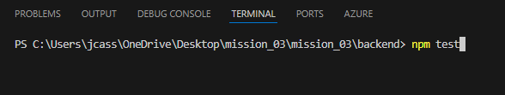

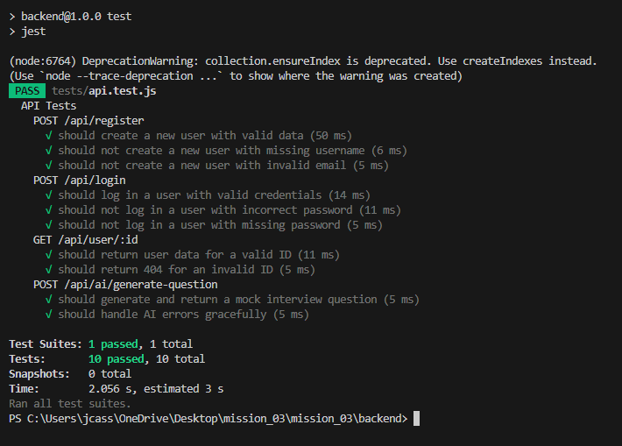

### **Week 3: Final Development, Presentation, and Submission**

#### **Project Coordinator and QA Specialist (You)**

* **Conduct Final Testing**
  + Perform thorough testing (Due: Mid Week 3)
  + Ensure all bugs are fixed (Due: End of Week 3)
  + Document final test results
* **Compile and Submit Project Materials**
  + Compile all documentation (Due: End of Week 3)
  + Review and finalize documentation (Due: End of Week 3)
  + Submit project materials (Due: End of Week 3)

#### **Frontend Developer and UX/UI Designer (John)**

* **Make Final Design Adjustments**
  + Gather final feedback (Due: Early Week 3)
  + Implement necessary changes (Due: Mid Week 3)
  + Ensure design consistency (Due: End of Week 3)
* **Prepare Presentation**
  + Create slides and materials to explain the design and frontend development process (Due: End of Week 3)
  + Prepare to demonstrate the frontend during the presentation (Due: End of Week 3)

#### **Backend Developer and API Specialist (Tajul)**

* **Finalize Backend Functionalities**
  + Ensure all endpoints are functional (Due: Early Week 3)
  + Conduct final testing of backend (Due: Mid Week 3)
  + Optimize performance (Due: End of Week 3)
* **Prepare Presentation**
  + Create slides and materials to explain the backend development process and API integration (Due: End of Week 3)
  + Prepare to demonstrate the backend during the presentation (Due: End of Week 3)

#### **Mob Programming Sessions**

* **Final Adjustments and Testing (Monday-Wednesday)**
  + Schedule: Daily 2-hour session
  + Focus: Making final adjustments, integrating all components, and thorough testing.
  + **Driver Rotation:** Rotate driver role every 30 minutes.
* **Presentation Preparation (Thursday)**
  + Schedule: Daily 2-hour session
  + Focus: Preparing and rehearsing the presentation.
  + **Driver Rotation:** Rotate driver role every 30 minutes.

### **Git Workflow**

* **Daily Pushes:**
  + Each team member pushes their work at least once a day.
  + Pull the latest changes from Git at the start of each work session.
* **After Major Changes:**
  + Push your work after completing significant tasks or features.
* **Before and After Meetings:**
  + Push the latest changes before any scheduled team meetings.
  + Push the updated work after making discussed changes.

### **Daily Standups**

* **Schedule:** 10 minutes each day at a fixed time.
* **Structure:**
  + Each member shares what they worked on yesterday, what they will work on today, and any blockers they are facing.
* **Follow-Up:**
  + Document any blockers or issues raised during the standup.
  + Follow up with team members to help resolve any issues.